**DAILY ONLINE ACTIVITIES SUMMARY**

|  |  |  |  |  |  |  |  |  |
| --- | --- | --- | --- | --- | --- | --- | --- | --- |
| **Date:** | **12/06/2020** | | | | | **Name:** | **NAIPUNYA VINOD NAIK** | |
| **Sem & Sec** | **IV SEM & A SECTION** | | | | | **USN:** | **4AL18CS050** | |
| **Online Test Summary** | | | | | | | | |
| **Subject** | | **N/A** | | | | | | |
| **Max. Marks** | | **N/A** | | **Score** | | | **N/A** | |
| **Certification Course Summary** | | | | | | | | |
| **Course** | **INTRODUCTION TO PROGRAMMING** | | | | | | | |
| **Certificate Provider** | | | **GREAT LEARNING**  **ACADEMY** | | **Duration** | | | **5.5 HRS** |
| **Coding Challenges** | | | | | | | | |
| **Problem Statement:1)** [**Given two positive integer start and end. The task is to write a Python program to print all Prime numbers in an Interval.**](https://github.com/orgs/alvas-education-foundation/teams/2nd-year/discussions/115) | | | | | | | | |
| **Status:-EXECUTED** | | | | | | | | |
| **Uploaded the report in Github** | | | | | **YES** | | | |
| **If yes Repository name** | | | | | <https://github.com/naipunya-naik/lockdown-coding/blob/master/PYTHON%20CODING/prime_12-06-2020.py> | | | |
| **Uploaded the report in slack** | | | | | **YES** | | | |

Online Test Details: (Attach the snapshot and briefly write the report for the same).

NO INTERNALS CONDUCTED

Certification Course Details: (Attach the snapshot and briefly write the report for the same).

* YESTERDAY, ON 11 JUNE 2020, I ATTENDED A WEBINAR ON SKILL DEVELOPMENT.
* TODAY , I RECEIVED A CERTIFICATE OF PARTICIPATION.



CERTIFICATION COURSE NAME:- INTRODUCTION TO PROGRAMMING

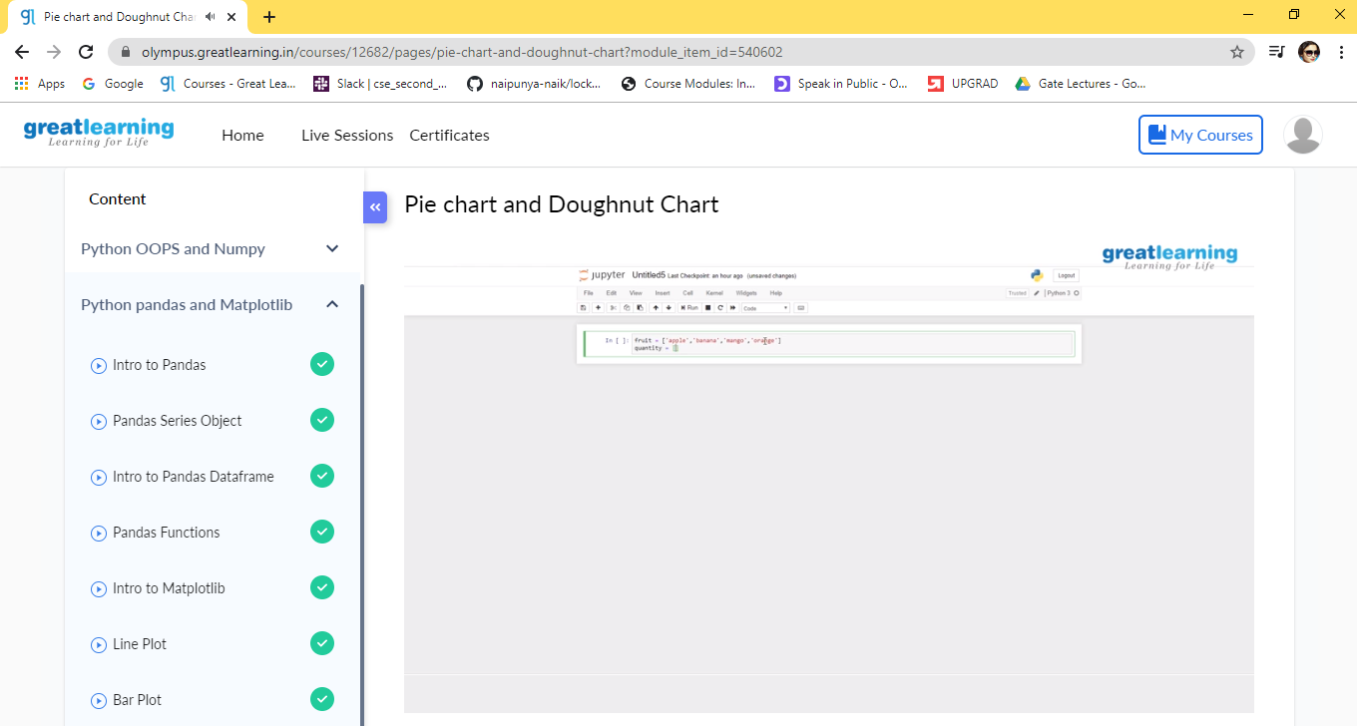

TOPICS COVERED ON 12 JUNE 2020:-

* [Intro to Pandas](https://olympus.greatlearning.in/courses/12682/pages/intro-to-pandas?module_item_id=540592)
* [Pandas Series Object](https://olympus.greatlearning.in/courses/12682/pages/pandas-series-object?module_item_id=540593)
* [Intro to Pandas Dataframe](https://olympus.greatlearning.in/courses/12682/pages/intro-to-pandas-dataframe?module_item_id=540594)
* [Pandas Functions](https://olympus.greatlearning.in/courses/12682/pages/pandas-functions?module_item_id=540595)
* [Intro to Matplotlib](https://olympus.greatlearning.in/courses/12682/pages/intro-to-matplotlib?module_item_id=540596)
* [Line Plot](https://olympus.greatlearning.in/courses/12682/pages/line-plot?module_item_id=540597)
* [Bar Plot](https://olympus.greatlearning.in/courses/12682/pages/bar-plot?module_item_id=540598)
* [Scatter Plot](https://olympus.greatlearning.in/courses/12682/pages/scatter-plot?module_item_id=540599)
* [Histrogram](https://olympus.greatlearning.in/courses/12682/pages/histrogram?module_item_id=540600)
* [Box Plot and Violin Plot](https://olympus.greatlearning.in/courses/12682/pages/box-plot-and-violin-plot?module_item_id=540601)
* [Pie chart and Doughnut Chart](https://olympus.greatlearning.in/courses/12682/pages/pie-chart-and-doughnut-chart?module_item_id=540602)

Coding Challenges Details: (Attach the snapshot and briefly write the report for the same)

[PROBLEM STATEMENT 1:- Given two positive integer start and end. The task is to write a Python program to print all Prime numbers in an Interval.](https://github.com/orgs/alvas-education-foundation/teams/2nd-year/discussions/115)

|  |
| --- |
| Explanation : A prime number is a natural number greater than 1 that has no positive divisors other than 1 and itself. The first few prime numbers are {2, 3, 5, 7, 11, ….}. The idea to solve this problem is to iterate the val from start to end using a for loop and for every number, if it is greater than 1, check if it divides n. If we find any other number which divides, print that value. |

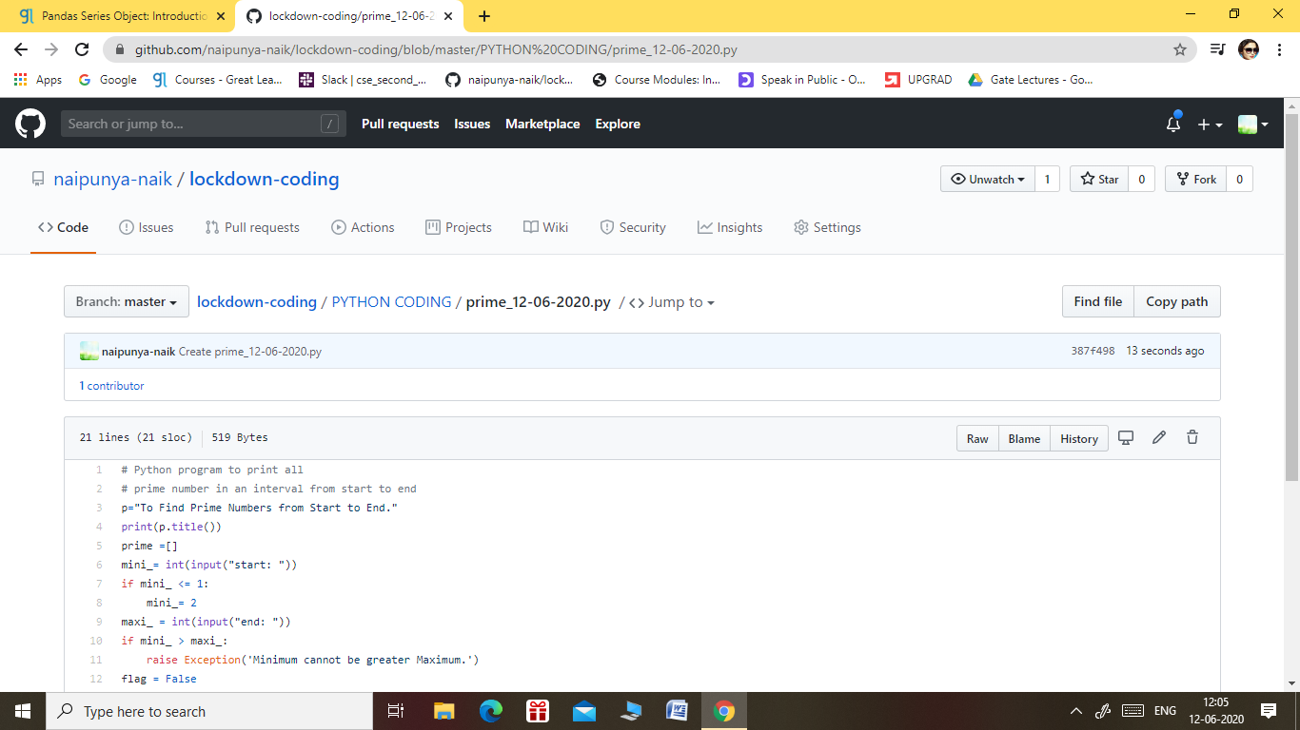

GITHUB REPOSITORY LINK:-

<https://github.com/naipunya-naik/lockdown-coding/blob/master/PYTHON%20CODING/prime_12-06-2020.py>